Hale CEVC Primary School
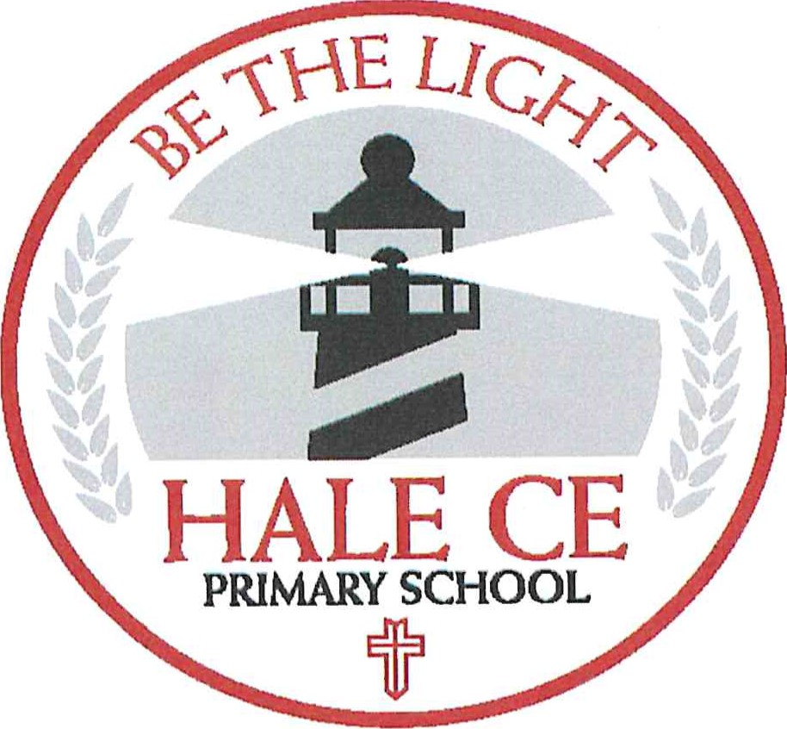
English Policy
(Phonics, Reading and Writing)
September 2022
Our vision is founded on Matthew 5: 14-16
‘Be the Light’

“You are the light of the world. A city set on a hill cannot be hidden. Nor do people light a lamp and put it under a basket, but on a stand, and it gives light to all in the house. In the same way, let your light shine before others, so that they may see your good works and give glory to your Father who is in heaven.” (Matthew 5:14-16)

Reading
Intent:
Here at Hale CEVC Primary School we wish to develop a love of reading in all children and to prepare our pupils with the skills they need to manage the demands of secondary school. We aim for our children to become independent, fluent and enthusiastic readers, who read widely and frequently with the skills to access, engage with and enjoy a wide range of texts.
We ensure the foundations for becoming life-long readers are set as soon as children enter our early year's foundation stage, All children have access to a wide range of quality texts and genres which will enable them to develop a life-long love of reading. Texts are chosen to enable children's written and oral vocabulary to be enhanced.
Reading is taught in many ways across school. Some of which include: daily phonics lessons and reading practice sessions, using Little Wandle in EYFS and KSI, whole class reading through Pathways to Read followed by grouped reading in KS2, 1:1 reading to an adult, independent reading for pleasure and home reading using Reading Plus.
At Hale C of E, our reading curriculum ensures a progressive and sequential build- up of knowledge and skills with repetition of these skills built in. From Y2- Y6, Pathways to Read is used to support our English curriculum. It follow a mastery learning model. Key skills are taught and repeated; there are multiple opportunities throughout each unit to use and apply the skills until they can be mastered fully. Within each sequence, there are opportunities for both shared and grouped teaching of reading. There are multiple opportunities for pupils to apply their skills in follow-on reading tasks.
Implementation:
Refer to the following documents:
- Phonics and Early Reading Policy
- Hale C of E Reading Methodology
Lowest 20%
All class teachers identify children who are in the lowest 20% of their class in reading. This is discussed in pupil progress meetings each half term and plans are put in place to accelerate progress and support further. Additional phonic Rapid Catch-Up sessions are used in addition to targeted reader support and specific reading sessions.

Intent
At Hale Primary School we believe that all our children can become fluent readers and writers. We aim to develop each child so that they are able to read with fluency as well as develop a love of reading that will stay with our children all their lives. This is why we teach reading through Little Wandle Letters and Sounds Revised, which is a systematic and synthetic phonics programme. We start teaching phonics in Reception and follow the Little Wand/e Letters and Sounds Revised progression, which ensures children build on their growing knowledge of the alphabetic code, mastering phonics to read and spell as they move through school.
This is our first year of beginning the Little Wandle Letters and Sounds Programme. The aim is for all of our children are able to tackle any unfamiliar words as they read. At Hale Primary School we also model the application of the alphabetic code through phonics in shared reading and writing, both inside and outside of the phonics lesson and across the curriculum. We have a strong focus on language development for our children because we know that speaking and listening are crucial skills for reading and writing in all subjects.
At Hale Primary School, we value reading as a crucial life skill. Our goal is that by the time children leave us, they read confidently for meaning and regularly enjoy reading for pleasure. Our readers are equipped with the tools to tackle unfamiliar vocabulary. We encourage our children to see themselves as readers for both pleasure and purpose.
We have a Reading Leader who drives the early reading programme in our school. This person has experience of teaching phonics and reading, and they monitor and support our reading team, so everyone teaches with fidelity to the Little Wand/e Letters and Sounds Revised programme.

Implementation
Daily phonics lessons in Reception and Year ll. and Year 2
We teach phonics for 30 minutes a day. In Reception, we build from 10-minute lessons, with additional daily oral blending games, to the full-length lesson as quickly as possible. Each Friday, we review the week's teaching to help children become fluent readers.
- Children make a strong start in Reception: teaching begins in Week 2 of the Autumn term.
- We follow the Little Wandle Letters and Sounds Revised expectations of progress: Children in Reception are taught to read and spell words using Phase 2 and 3 GPCs, and words with adjacent consonants (Phase 4) with fluency and accuracy.
- Children in Year 1 review Phase 3 and 4 and are taught to read and spell words using Phase 5 GPCs with fluency and accuracy.
- This year, as it is our first year teaching Little Wandle the children in Year 2 will be retaught Phase 5 in Autumn 1 and Autumn 2 using the placement assessment tool.
Daily Keep-up lessons ensure every child learns to æad
- Any child who needs additional practice has daily Keep-up support, taught by a fully trained adult. Keep-up lessons match the structure of class teaching, and use the same procedures, resources and mantras, but in smaller steps with more repetition, so that every child secures their learning.
Catch — up and Rapid catch up
e This year, as it is our first year teaching Little Wandle the children in Year 2 will be retaught Phase 5 in Autumn 1 and Autumn 2 using 'catch- up' e From Spring 1, we will timetable Rapid Catch up daily phonics lessons for any child in Year 2 who is has not passed the Phonics screening check or has not completed the exit to Little Wandle assessment which checks for fluency.
e Any child in Year 3 to 6 who did not pass the Phonics screening check and can not read with fluency with will access the Rapid Catch up programme which will be delivered by a fully trained adult. These children urgently need to catch up, so the gap between themselves and their peers does not widen. We use the Little Wandle Letters and Sounds Revised assessments to identify the gaps in their phonic knowledge and teach to these using the Keep-up/Rapid keep-up resources — at pace.
Teaching reading: Reading practice sessions three times a week
- We teach children to read through reading practice sessions three times a week. These:
- are taught by a fully trained adult to small groups of approximately six children o use books matched to the children's secure phonic knowledge o are monitored by the class teacher, who rotates and works with each group on a regular basis.
- Each reading practice session has a clear focus, so that the demands of the session do not overload the children's working memory. The reading practice sessions have been designed to focus on three key reading skills: o decoding o prosody: teaching children to read with understanding and expression o comprehension: teaching children to understand the text.
- In Reception these sessions start in Week 4. Children who are not yet decoding have daily additional blending practice in small groups, so that they quickly learn to blend and can begin to read books. These children will have access to a picture book and a reading for pleasure book to take home in their story sack.
- In Year 1 these session begin from week 1.
- In Year 2 and 3, we continue to teach reading in this way for any children who still need to practise reading with decodable books. The children will have access to orange, turquoise and purple reading practise session books. In Year 3 the children will have access to the Rapid Catch Up Little Wandle books (age 7+ - these books are available to purchase from Oct 22)
Home reading
^{e} The decodable reading practice book is taken home to ensure success is shared with the family after the third reading practise session.
- Reading for pleasure books also go home for parents to share and read to children.
- Parent videos are available on our website o Parents are invited in for reading workshops o Parents of children in Reception are invited in to take part in a phonics/reading session o Children/families have access to Little Wandle e-books at home
[insuring consistency and pace of progress
e Every teacher in our school has been trained to teach reading, so we have the same expectations of progress. We all use the same language, routines and resources to teach children to read so that we lower children's cognitive load.
e Weekly content grids map each element of new learning to each day, week and term for the duration of the programme.
e Lesson templates, prompt cards and how to videos ensure teachers all have a consistent approach and structure for each lesson.
^{e} The Reading Leader and SLT use the Audit and Prompt cards to regularly monitor and observe teaching; they use the summative data to identify children who need additional support and gaps in learning.
- The final week of each half term is an assessment and review week. Children will be assessed by the class teacher using The Little Wandle Assessment website. This will identify any gaps which need to be retaught and will during this week and will match children to a suitable reading book.
Ensuring reading for pleasure
We value reading for pleasure highly and work hard as a school to grow our Reading for Pleasure pedagogy.
We read to children every day. We choose these books carefully as we want children to experience a wide range of books, including books that reflect the children at Hale Primary School and our local community as well as books that open windows into other worlds and cultures.
- Every classroom has an inviting book corner that encourages a love for reading. In Reception, children have access to the reading corner every day in their free flow time and the books are continually refreshed
- All children in school have a reading record which is taken home each night. The parent/carer records comments to share with the adults in school and the adults will write in this on a regular basis to ensure communication between home and school As the children progress through the school, they are encouraged to write their own comments and keep a list of the books/authors that they have read.
The school library is available for classes to regularly use. Children across the school have regular opportunities to engage with a wide range of Reading for Pleasure events (book fairs, author visits and workshops, national events etc).
- Each class has the Pie Corbett reading spine books to share with the children and we ensure in reception we have high quality texts throughout the provision for children to access.

Pathways THE LITERACYCOMPANY
e o Literacy
Pathways to Read
Methodology and
User Guide for Teachers
Hale C of E Primary School
1

Pathways
O Literacy
Pathways to Read
Contents
 | 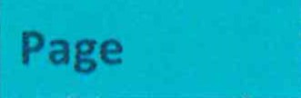
The plans and teaching sequence | 3
- Whole class shared reading session | 4
- Using the PowerPoints | 4
- Grouped reading session | 5 -6
- Follow on task | 6
- Key stage 1 recommendations | 7
Reading models | 8 - 9
Curriculum coverage and mastery skills | 10 - 12
Recording and assessment | 13
Use of longer novels
Supporting documents | 14
Frequently asked questions | 15 - 16
Pathways to Read
Methodology and User Guide
The | lans and teachin | se | uence
Each unit of work is expected to last a half term, There are 6 whole class reading sessions provided per unìtt One whote class shared reading lesson is recommended to be taught per week with time after that lesson for a more bespoke grouped read with a smaller number of pupil¶
tn the shared and grouped read, there is a clear teaching focus with the opportunity to master key reading skills in the session and other sessions in the hatf term. There are follow on reading tasks to enable pupils to evidence the skills they have mastered independently.
This guide wìll provide further details on all the aspects of Pathways to Read to enable the teacher to manage and teach it effectively in their classes,
le clas shared readin session:
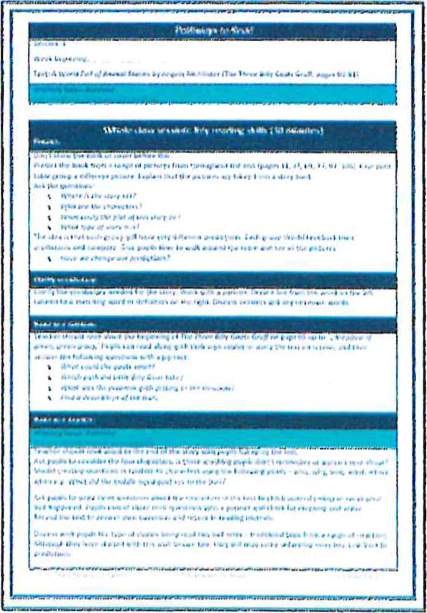
The whole class session should always be taught to alt pupils before the grouped read or follow on tasks,
The session is around 30 minutes long with roughly 5-10 minutes per section of the lesson, It should be taught at a fast pace,
Reading aloud by the teacher should be modelled at a suitable pace (age-appropriate) with timers set for pupils to answer questions quickly with a partnecc
A variety of ways to read should be practised and adapted for the needs of your class. In autumn, teacher modetlìng ìntonation and pace of reading is planned more regularly. As pupìts move through the programme, more paired and independent reading in the whole class section witl be practised% It would also be appropriate for teachers to facilitate tìmed speed reads to develop paces
These are the recommended reading practices:
- Teacher reads aloud to model intonation and fluency while pupils are following the text
- Teacher reads aloud to model intonation while pupils are reading aloud alongside the teacher
- Pupils read in pairs quietly (same or mixed ability) —supportive role to be carried out where appropriate o Pupils read the text silently at own pace o Pupils read a section of text in an allocated time to improve fluency
Pupils should work in mixed ability groups and pairs. Set a clear routine with specific places for pupils to sit. Pupils will be asked to work independently, with a partner or in a small group as part of the shared session. Discussion of answers should be encouraged. Consider reading abilities: pair pupils who are weak word readers with strong word readers with poor comprehension skills, for example. You may wish to have a target group who sometimes work with the teacher (or teaching assistant) and have the sections of text read aloud to them. Adults should facilitate appropriate discussion.
The shared lesson always follows a four-part structure: Predict, clarify vocabulary, read and retrieve, and read and explain (where the mastery focus is taught and practised). You can be flexible with this, especially while you are getting Pathways to Read up and running — you might find, for example, in a year 3 class, to establish routines effectively you focus on 3 parts of the lesson.
Using the PowerPoints:
- Each shared reading lesson comes with a PowerPoint for delivering the sessions. All objectives, mastery skills, questions and activities are presented on the slides. They should be used in conjunction with the plan as the plan holds additional information to support the teacher. Answers to the 'Read and Explain' section of the lesson are included on the PowerPoint to support teachers with discussion of pupils' responses.
- Where you see an orange box on the PowerPoint, read the instructions to insert an appropriate picture from the text. These images could not be included for copyright reasons.
e All six PowerPoints for each of the six lessons come as one document.
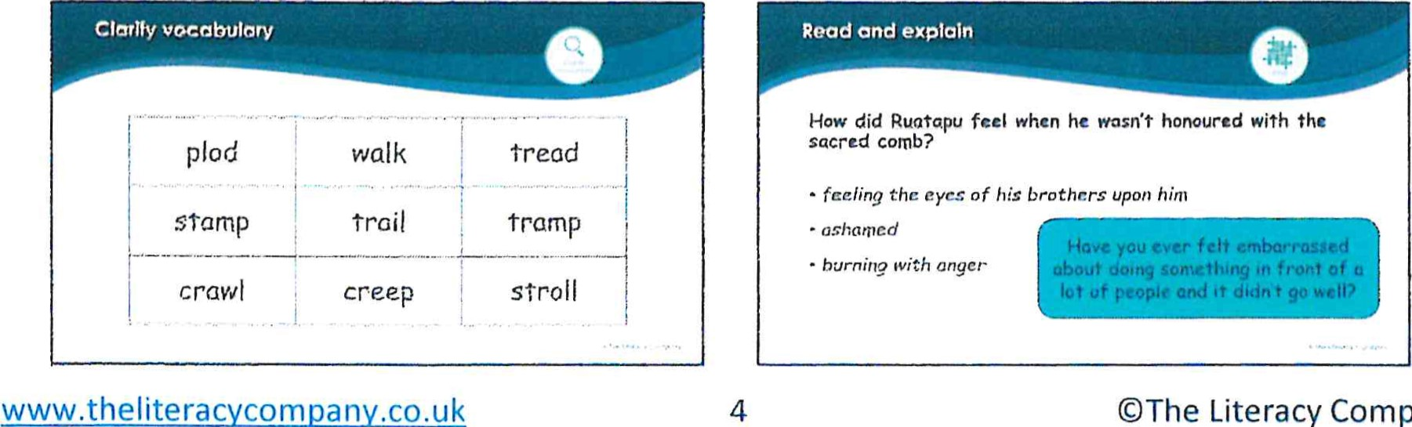

Classes divided into four groups e,g, two groups of 8 and two groups of 7, Where possible have the lowest numbers of pupils in your lowest attaining groupst
The groups should be created based on reading ability (both word reading and comprehension should be considered),
Example groupings:
Higher attainers targeted GOS by end of Su2 | Middle attatners targeted EXS by the end of Su2 | Middle and just below attainers  = targeted EXS with some WTS by end of Su2 | SEND learners below attainers expected to be  WTS by end of Su2
Higher and middle attainers  targeted GOS and hìgh EXS by end of su2 | Higher and middle attainers  targeted GDS and high EXS by end of su2 | Middle and just below attainers  - targeted EXS with some WTS by end of Su2 | SEND learners below attainers expected to be  WTS by end of su2
In KS24 it woutd be appropriate for pupils in the middle and lowest attaining groups to participate in their grouped read as soon after the shared read as possible, and before the on tasks, More confident readers can carry out pre-reading tasks or the follow* on task with less support and preparation,
It is recommended that teaching assistants support each class during reading sessions, This way, in a class, two grouped reads can be carried out simultaneously,
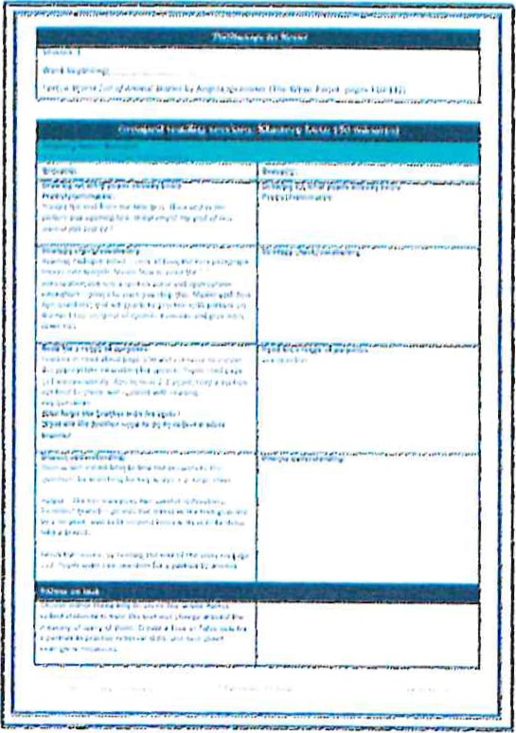
The right-hand swe of the plan has been left blank for the teacher to adapt the session to suit the needs of pupìts, For pupils working above and below year group expectations, the 'Progression in Reading' skìlts document should be used to differentiate the main sessìom Adapt the comptexity of the questions and the expectation for independent reading to support and challenge groups of pupils,
- Similarly to the whole class session, each grouped reading session also has four parts:
Drawing on what pupils already know  Predict/summarise | A short discussion, no more than 5 minutes, linking topic or the theme of the text to prior knowledge. This supports prediction and inference.  Pupils should then either summarise previous reading or predict what will happen in the section of text to be read,
Strategy check/ vocabulary | A reading strategy is practised here e.g. visualisation, reading aloud, working out unknown words.  Alternatively, vocabulary needed for the section of text may be discussed.
Read for a range of purposes  Key question (mastery focus) | This is the section of the lesson for independent reading of the text. Pupils should read on their own with the teacher listening in to 2 or 3 pupils in the session.  A key question based on the mastery skills is presented and pupils should answer it on a post-it when they have finished reading.
Discuss understanding | Enjoy this final part of the session by discussing pupils' answers to the key question and addressing any misconceptions. Discuss any further thoughts or queries.
Grouped reading with texts pitched to suit pupils' needs:
- The aim at Hale C of E Primary is for pupils to engage with the whole class text as part of their grouped reading sessions. However, if they require texts at a different pitch to support with their reading progress, these wilt be chosen by the class teacher from the appropriate range of levelled texts e.g. Collins Big Cat texts. The mastery skills will remain the same as the shared text focus, but the pitch will be adapted using the Progression in Reading skills document.
Follow on tasks:
- Tasks have been created to further practise the mastery skills taught in the shared and grouped reading sessions. These are straightforward, easy to follow tasks which allow for independent reflection on reading. They may also involve re-reading of the texts or pre-reading before grouped sessions. Repetition of follow-on task activities is recommended.
- Pupils at Hale C of E will have a reading journal to collate these tasks as well as some of the extended answers to questions in the shared or grouped reading sessions.
- Some groups of pupils will complete the follow- on tasks after the shared read and some will complete them after both the shared and the grouped read.
- If lower attaining readers have accessed a different text for their grouped read, the teacher may need to adapt a follow- on task to match the book.
Ke -ta el recommendations:
tn year 2 foltowìng the completion of Little Wandle reading practice session, Pathways to Read shoutd be introduced (expectation is spring 1), Some of the shared reading sessions have three, rather than four sections, usually when the text is non-fiction, This attows more time to teach Y2 pupils the skills of retrieval and explaining key facts, These lessons follow 3 parts: predict} clarify and retrieve as a mastery focus,
In most grouped reading sessions, pupils will be expected to re-read the text from the shared session, This is to enable pupils to gain a greater understanding of the text and to pract\se their word reading and fluency (building on from reading practice sessions),
Not all groups wìtl complete the grouped read as suggested in the unit. Some of the lower attaining groups witl still need to practìse their word reading through a phonically decodable text linked to Little Wandle expectationst
To support with moderation and teacher assessment of reading, a tist of common exception words, polysyllabic words and words with common suffixes is at the front of each unite The teacher wilt then know the types of word read in each text,

Reading model at Hale C of E Primary School

Effective reading carousel
This model is an example of a suitable carousel for KS2 at Hale CE Primary School. In KSI during the TA grouped read, pupils will have the opportunity to re-read the text to practise prosody (fluency and intonation).
Three-day model - with a TA
Monday | Whole class shared read
Groups |  | MA 2
Tuesday | Pre-read | Grouped read TEACHER | Grouped read
Wednesday | Grouped read TEACHER | Re-read/ pre-read/ read for pleasure | Grouped read
Thursday | Follow-on task for all pupils with directed adult support  Grouped reading with teacher/ TA for selected groups (where required),
Friday | Reading for pleasure/ complete follow-on task

Y3 Y4 and Y6
Monday | Whole class shared read
Groups |  |  | MA 2
Tuesday | Grouped read TEACHER | Reading for pleasure | Comprehension task linked to whole class task | Re-read with adult support
Wednesday | Comprehension task linked to grouped read | Pre-read with adult support | Grouped read TEACHER | Reading for pleasure
Thursday | Reading for pleasure | Grouped read TEACHER | Challenge read | Pre-read with adult support
Friday | Follow-on task |  |  | Grouped read TEACHER
(O
Key-snag-o ^{n} e model
Carouset
This model is an example of a suitable carousel for KSI at Hate CE Primary School when Pathways to Read is implemented in Y2 during the spring term. Pupils will focus mainly on comprehension in the shared session, tn the grouped session with the teacher, pupils wilt have opportunities to pr•actise word reading by rereading the same text alongside further teaching and practice of comprehension skills, During the TA grouped read, pupils will have the opportunity to re-read the text to practise prosody (fluency and intonation),
HA and MA 1 group to rotate to ensure teacher reads with each group once a fortnight.
Monday | 30 minutes | Whole class shared read
 |  |  |  | MA 2 | LA/ SEND
Tuesday | 20 minutes | Pre-read | Group read with a focus on comprehension | Grouped read with a focus on prosody TA | 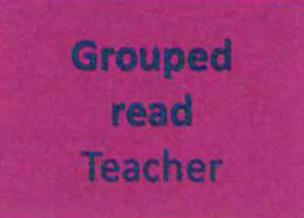
Wednesday | 20 minutes | Grouped read TA | Grouped read Teacher | Reading for pleasure | Grouped read with a focus on fluency TA
Thursday | 20 minutes | Grouped read TA | Reading for pleasure | Grouped read Teacher | Grouped read with a focus on prosody TA
Friday | 30 minutes | Follow-on task

Curriculum coverage and mastery skills
The national curriculum for reading comprehension has been divided into three sections in Pathways to Read: ongoing skills, core skills and mastery skills.
Ongoing skills
— taught throughout all reading lessons and within a variety of classroom activities
 | Key stage 2 ongoing skills
Year 2:  Listen to, discuss and express views about a wide range of contemporary and classic poetry, stories and non-fiction at a level beyond that at which they can read independently  Become increasingly familiar with and retell a wider range of stories, fairy stories and traditional tales  Participate in discussion about books, poems and other works that are read to them and those that they can read for themselves, taking turns and listening to what others say  Explain and discuss their understanding of books, poems and other material, both those that they listen to and those that they read for themselves  Recognise simple recurring literary language in stories and poetry  Draw on what they already know or on background information and vocabulary  Check that the text makes sense to them as they read and correct inaccurate reading  Recognise simple recurring literary language in stories and poetry | Year 3 and 4:  Listen to and discuss a wide range of fiction, poetry, plays, non-fiction and reference books or textbooks  Read books that are structured in different ways and read for a range of purposes  Increase their familiarity with a wide range of books, including fairy stories, myths and legends, and retell some of these orally  Check that the text makes sense to them and discuss their understanding  Participate in discussion about books  Year 5 and 6:  Continue to read and discuss an increasingly wide range of fiction, poetry, plays, non-fiction and reference books or textbooks  Read books that are structured in different ways and read for a range of purposes  Increase their familiarity with a wide range of books, including myths, legends and traditional stories, modern fiction, fiction from our literary heritage, and books from other cultures and traditions  Participate in discussion about books  Explain and discuss understanding of reading  Recommend books to peers  Provide reasoned justifications for views

Core skills
Key stage 1 skills mastery skills
Discuss the,ìr• favouflte words and phrases (la)  Answer and. ask questions (1b)  introduce non-fiction books that are structured in different ways (1b)  Oìscuss the sequence of events in books and how items of information related (lc)  Make inferences on the basis of what is being said and done (Id) | Summarise the main ideas from more than one paragraph (2c)  Draw inferences (inferring characters' feelings, thoughts and motives from their actions) and justify with evidence (2d)  o Identify and discuss themes and conventions (2d) o Distinguish between fact and opinion (2d)  Identify how language, structure and presentation contribute to meaning (20  Evaluate authors' language choice, including figurative language (2g)  Make comparisons within and across books
pupils are given regular opportunities to futly master these crucial reading skills in each shared session
 | Predìct what might happen on the basis of what has been read so far (te)  Otscuss and clarify the meaning of worL linking new meanings to known vocabulary  Answer and ask questions (1b) |  |  |  | Predict what might happen from details stated and implied (2e)  Explore the meaning Of words in context  (2a) record and present information
 |  | s - | skills

these are taught as a focus skill shared and grouped reading
In every year group (Y2=Y6) in each half term, 2 or 3 mastery skills have been identified as the focus skÌtts to be taught in that unìtz Activities and questions based on these reading skitts are taught, repeated and practisedt Each objective is a focus at least twice across a
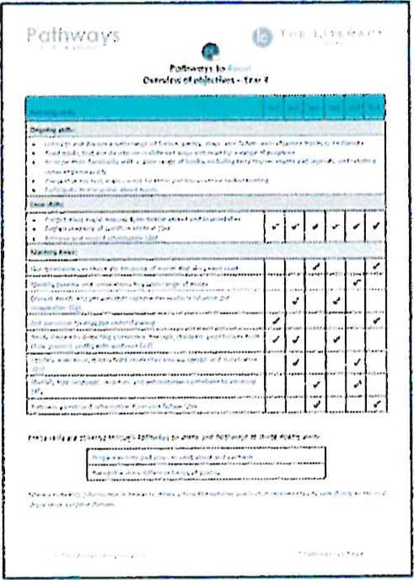
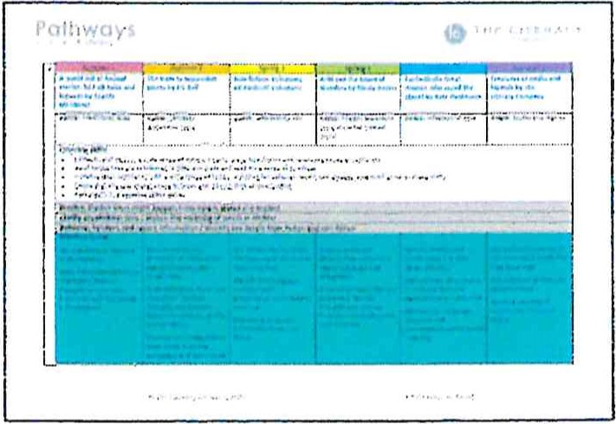
To support development of reading skills, an additional document has been produced to support the delivery of Pathways to Read. It is called 'Progression in Reading Skills'. This document has been used to ensure progression in all the reading skills in the lessons, This can be used for differentiation of grouped reading questions and mastery focus.
Pathways  Pathways to Read  Progression in Reading Skills | 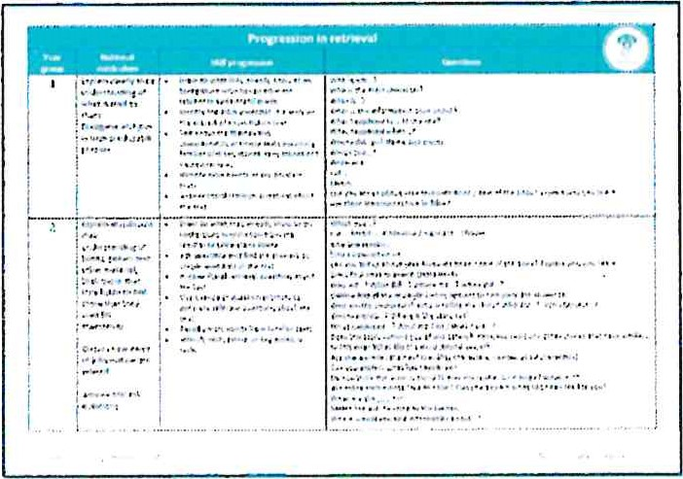

Skills overview
There is an overview of the reading skills and texts provided for each year group — this is your long-term plan for reading. There is an additional tick sheet overview of ongoing, core and mastery skills to show at a glance coverage and repetition of skills,

Recording and Assessment
Every pupil within the class will have a reading journal where they can collate answers to questions and fotlow= on tasks, In the shared session, some of the questions are suitable for a quick fire/whìteboard/post=it note type answer, whereas some need a more detailed exptanatìon or require a tick box/matching tines/number order responset The latter should ^{b} e recorded or stuck in reading journals and can be marked by pupils, either by themselves or by a peer, within the lesson: Pupits will be asked to record the mastery skill as a titte to these questions usìng the symbol on the PowerPoint This would give teachers a quick, at a glance, assessment of a pupil's ability across the reading skills covered.
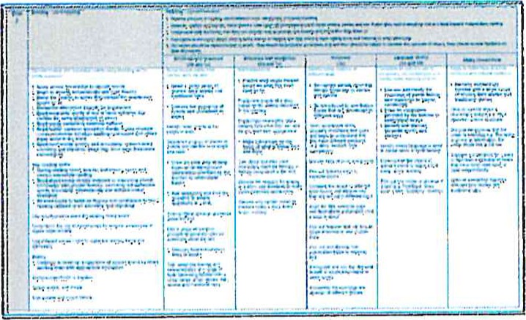
tn the shared and grouped sessions, teachers witl use Hale C of E half-termly assessment s ^{h} eets to record ongoing responses within the sessions. Pupils may answer the main question on a post-it note and hand in their post-it note to the teacher at the end of the sessìom These can stay with the assessment sheets where suitable,
The assessment sheets are strengths and weaknesses. This information will provide clear and concise assessment information for making end of term judgements on INSIGHT and wilt also provide a wealth of ìnfoemation for moderation across classes/year groups.
tn key stage one, It is important that teachers make notes on individual pupils' fluency, types of words being read and verbal responses to some retrieval and comprehension questions. This tnfor•matìon is needed to make end of key stage assessments,
^{R} eading assessment grids for each year group have been included in Pathways to Read for teachers to use as a tool to support assessment of groups or individuals. Each grid provides the whole year group curriculum on a single page for ease of reference.

The use of longer novels
In some of the units, a longer novel is used. Not all the novel is always used for the reading lessons. When there is still some of the book left to be finished, we would recommend that you continue to read the novels aloud for pleasure through the next half term. Older pupils may wish to continue to read copies of the text independently. The longer novels are often also recommended as class readers in Pathways to Write if this is being used in conjunction with Pathways to Read,
In some units where a longer novel is used, there is a weekly reading expectation. At the end of the weekly lesson plans, there may be a note to continue reading to a specific page before the next session.

Supporting documents
There are several documents in addition to the planning and PowerPoints to support teachers with delivery of the Pathways to Read programme:
- Texts and Objectives Overview — Y2-Y6
- Progression in Reading Skills
Reading Assessment Grids: Year 1 to Year 6
Follow up tasks:
tasks are created to further practice the mastery skills taught in the shared and grouped reading sessions These are easy to follow tasks which allow for independent reflection on reading
They may also involve rereading of the text or pre reading before grouped sessions
A reading reflection book is used to collate these tasks which will include: a follow-on task from guided reading session, a follow on task from whole class pathways and where appropriate independent application in an unseen text e.g. author study focus
(This has been developed with our literacy partner to address gaps in learning identified in termly progress meetings, to strengthen independent application of comprehension from discussions arising in pupil progress reviews)
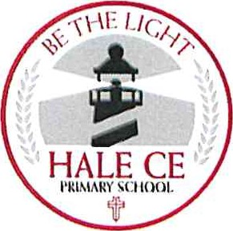
Pathways to Read — Whole Class Session
- Whole class approach, clear objectives, mastery skills, questions and objectives
- Pupils work in mixed ability groups and/or pairs (e.g. pupils who are weak word readers with strong readers with poor comprehension skills)
- Shared lesson always follows a 4-part structure: predict, clarify, read and retrieve and read and explain
(this is adapted in consultation with English lead to meet the needs of all children)
- Weekly focused mastery key with opportunities for revisit and review of previously taught keys
- Whole class approach fosters a vocabulary-rich environment to challenge and inspire all pupils and allows them access a genres, which would not be accessible independently
Grouped Reading Sessions:
Groups created on reading ability (both word reading and comprehension should be considered)
Reading assessments used to support all groupings (book banding, NFER, AFL)
Each session follows a 4 part reading structure (predict/summarise, strategy check/ vocabulary, independent reading, discuss understanding )
The skill introduced in the whole class Pathways session is further developed within these small group session, to allow children to apply the skill to a text appropriate to their age and stage Recommended reading practices include:
teacher reads aloud to model intonation and fluency whilst pupils follow the text teacher reads aloud to model intonation while pupils read aloud alongside the teacher pupils read aloud in pairs quietly — supportive role to be carried out where appropriate pupils read the text silently at own pace pupils read a section of text in an allocated time to improve fluency

Writing
Intent:
Here at Hale CEVC Primary School, we aim for our writing curriculum to have a progressive and sequential build- up of knowledge and skills with repetition of these skills built in.
We equip our pupils with the tools they need to write successfully and to meet their end of year age related expectations, while ensuring knowledge building connects across all subjects. We aim to use prior learning to embed understanding and build new learning while providing rich and varied learning opportunities to build confident and enthusiastic learners
Ultimately our goal is to prepare our pupils with the skills they need to manage the demands of secondary school.
Implementation
Pathways to Write is used to support our English curriculum. This follows a mastery-learning model. Key skills are taught and repeated; there are multiple opportunities throughout each unit to use and apply the skills until they can be mastered fully. Within each sequence, there are many opportunities for incidental short-burst writing with an extended written outcome built up to the end of each unit. Planning and activities are adapted as needed to suit the individual needs of all our learners.
Lowest 20%
All class teachers identify children who are in the lowest 20% of their class in writing. This is discussed in pupil progress meetings each half term and plans are put in place to accelerate progress and support further. Support for these learners may come in the form of Pathways to Progress tasks, small group intervention using our tutors or more individual short term support sessions.
Refer to the following documents:
- Pathways to Write Methodology
- Pathways to Progress Overview
September 2022
Pathways THE LITERACYCOMPANY
e Literacy
Pathways to Write
Methodology and
User Guide for Teachers
Hale C of E Primary School
C)The

Pathways
• e Literacy
Pathways to

Contents
 | 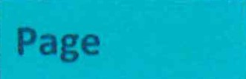
The Plans and Teaching Sequence | 3
Keys: Gateway, Mastery and Feature | 4
Coverage of National Curriculum Skills | 5
Developing Vocabulary and Working Wall Suggestions | 6
Pupils Working Below ARE | 7
EYFS | 7
Curriculum: Use of Novels and Wider Curriculum Links | 8
Recording and Assessment | 9
Supporting Documents | 9

Pathways to
Methodology and User Guide
The Plans and Teachin | Se | uence
Each unit of work ìs expected to tast weeks, The teaching sequence of each unit comprises of 15 sessions, but each sessìon may take longer than an actuat lesson depending on the ctass% The programme is designed. to allow teachers to have ownership rather than feeling that it should be followed in the same way by everyone,
Pgthways to Write follows a Mastery-teaming model, Key skills ate taught and cepeated; there are multiple opportunities throughout each unit to use and apply the skills until they can be mastered fullyt Within each sequence% there are many opportunities foe Incidental short- burst writing with an extended written outcome buìtt up to by the end of each unit,
The ideas and work are pitched at ARE, but there are suggested activities foe greater depth pupils in most lessons and for every final writing outcome, Foe pupils below ARE, it is important that planning is personalised and we qtve guidance on page 7 to support thist
Planning follows the sequence below: o Session Gateway
This ts an opportunity to hook the pupils into the context of learning and to assess previously taught. mastery A short writing task is set at the end of this session to assess the application of: Gateway skìlts, (The focus is on assessment of previously taught skills and is not intended to assess pupìts on skitts or genres that they have not been taught before.) Where pupils are struggling to apply and to use Gateways keys, these should be built into the planning of the unit to ensure more personatìsed learningt e, Sessions Pathway
In this section, the Mastery skills are introduced with many opportunities along the way to practìse and apoty these skills tn different writing tasks, The tasks use genres that the pupils be. most familiar with such as character or setting descriptions, dialogue, diary entries, instructions, poetry and sentence work, providing a range of on-going evidence for writing
assessment:
s Sessions Writeway
Thìs final section of the sequence comprises of 4 sessionst It begins with sectioning and sequencing texts using a model, If the final outcome is narrative based, then this witl usually ^{b}e the text which has been read or for youngef• pupils a shortened version to support retettìng has been included% If the outcome is a non-fiction text, then a model wilt be available i^{n} the resource sect•ìom Two sessions have been allocated for the writing of the text in the Wrìtegwqyž but this may be extended depending on the year group and what is being wr-ìttent Suggestions have been made as to how this could be structured but it needs to be responsive to pupils' needs, Within the Wrìteawayo pupils ate encouraged to plan, write, c^{h}eckÐ edit4 re^{z}draf:t and publish as required; with the focus on using and applying the mastery skìlts they have been taught,

Othe
The Keys: Gateway, Mastery and Feature
Gateway keys  (non-negotiables/basic skitts) | Mastery keys  (year croup national curriculum expectations) | Feature keŸ5  (vocabulary, manipulating sentences and tense, structure)
- Use punctuation at Y2 standard correctly 3tops, capita! letters • including for proper nouns, exclamation marks, question marks, commas in a list, apostrophes for contraction and singular noun possession)  - Use conjunctions and prepositions to express time, place and cause  Use adverbs to express time Group related ideas into paragraphs | Use adverbs to express time, placo and cause  Build an increasing range of sentence structures Use headings and subheadings to aid presentation  Assess the effectiveness of own and others' writing | Use persuasive language e.g. alliteration, repetition Write in logical order Use 2nd person or 3rd person to talk directly to the reader  Select organisational features e.g. opening statement, sub-headings, closing statement
The keys are listed at the start of each unit. Gateway keys are the skills that should have been previously taught. Mastery keys are the main skills that will be focused on throughout the unit. The 0---symbol is used each time there is a focus on a mastery skill Feature keys are the features of the writing genre that is the outcome for each unit. Each set of Feature keys has the same structure — vocabulary of the genre, how sentences and tenses are used and the overall structure of each one.
Feature keys
Feature keys are element of writing specific to the genre that is the outcome for each unit, Each set of Feature keys has the same structure — vocabulary of the genre, how sentences and tenses are used and the overall structure of each one. The Feature keys ensure that there is both consistency within the teaching of a genre across school and progression with the genre outcomes between year groups. The Feature Keys Progression document is a comprehensive guide on the features of each specific writing genre used within Pathways to Write.
Yl/2 | Y3/4 | Y5/6
Year 1:  some simple dosctilþtion  Write in person based on experiences  WI ite in past tense  Begin to link events using ond Write events In order  Yeat 2.  Include detail and description to iníorm the reactor  1.1%C' past tense  Include personal comments and viewpoint order events with adverbs of time | a balance of descripti'.)rt and opinion use a Of adverbs e.g. first. next, after that. finally and prv?positi011S the morning, lunch use range of past forms Write in r: person or person  Write an introductcuy paragraph  Write further paragraphs in chtcmlogical  Engage the reader thrc-suç,h detailed description  Ior.lude eyewitness acccnmts as quotr.s usillb' direct speech punctuation  t.lse fronted adverbials to intl or connect paragraphs e.g. Later that day,  Inside the castle use of tense fog ms Vv^{i}ritt? in F person or 3rd pet Write" an introductory paragroph including (he 5Ws — who, what. when, why and how  1.1se paragraphs to extend and sequence extended recounts | Recount Yea, 5:  - Eneage through use of description, feelihfi£, and opinions  - Create cohesion through of adverbs and  Write in consistent A of verb forms  - the 5W:, —who, what, when, why and how• alid with a clear %llmmttry  S€•lect the appropriate style to the audience  (lil and speech to  Of viewpoints  LISQ a wide range of  :.ynonvms, adverbials, punctoation verb t'•nses anil  BlogrnphY Autobiography  int-•lucle;  - use life mcllidirs?, dates place  - thematic spëclfic the subject formal Ian
Within each year group, a range of genre are covered to ensure the breadth required by the National Curriculum is achieved. These are both non-fiction and fiction with the Feature keys of the latter broken down into areas such as myths, fables, historical and fantasy. Not all genres are covered in every year group but writing outcomes have been carefully chosen to suit each specific year group; some outcomes are hybrid texts.
N-. •ional Curriculum Skills
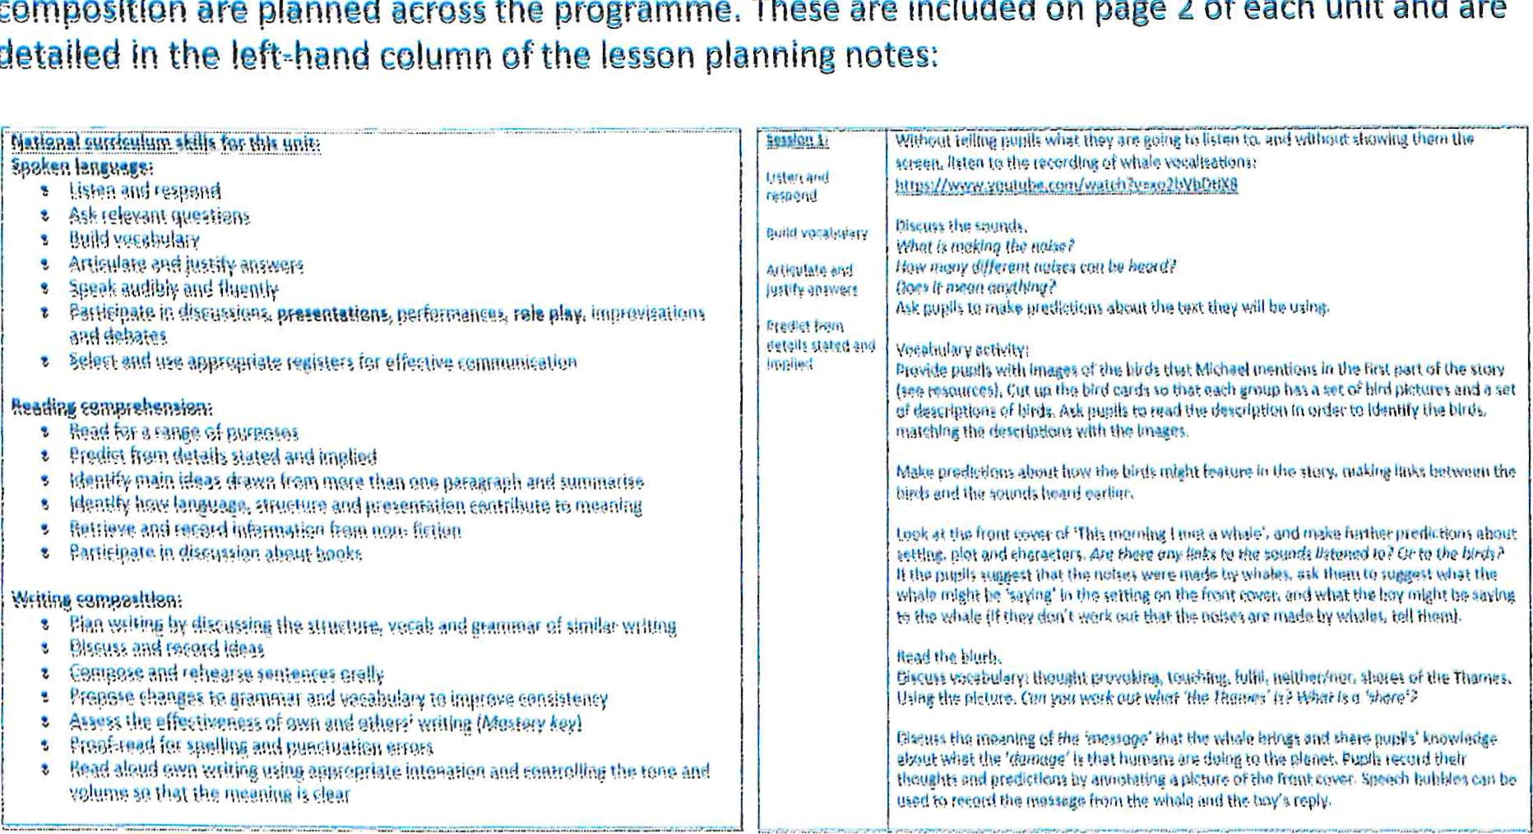
^{A} language, reading comprehension, and writing
lt
objectives
for
each
year
group
linked
to
spoken
composition
are
planned
across
the
detaž\ed
These are included on page 2 of each unit and are
C elemen •s not included in Pathwa s to Write
There are many opportunities for the application of phonics and spelling within the programme, However•4 schools witt need to have their own phonics, spelling and handwriting progtammes in place to ensure that att aspects of these are covered,

Working Wall Suggestions
At the start of each unit is a suggestion for creating a working wall. We recommend that the features of each genre are built up throughout the unit of work using the Feature keys for support and displayed on the working wall.

Developing Vocabulary
Alongside key writing skills, Pathways to Write also builds in extensive opportunities to develop and apply vocabulary. Vocabulary boxes are in every unit and give guidance on tiers of vocabulary and of the vocabulary that is developed within the unit. This includes opportunities for application of the word list words for years 3/4 and years 5/6 and common exception words for year 1 and year 2:
Developing vocabular_y
Developing a rich and varied vocabulary is a key skill which supports all areas of learning. Vocabulary falls into different categories:
Tier 1 — Day to day vocabulary usually spoken in the simplest form
e.g. bag, table, run, shop.
Tier 2— These words can have the same meaning as Tier 1 words. However, they are not used as frequently e.g. satchel, desk, sprint, grocery store. They can also be words which have more than one meaning.
Tier 3 -- These words are more technical and subject specific.
Vocabulary to explore within this unit:
NC Word List
actually knowledge although question consider sentence earth separate enough special guide therefore heart various increase weight important | protected creature surface bristly gulp slithers nudges feast shallows stranded | mammal blowhole baleen krill shrimp shoal sieve blubber  Equator dawn chorus

Pathways to Write aims to develop word depth with children by developing a planned approach to explaining words and meaningful, repeated exposure to them.
Pupìts Below ARE.
The document Progression in Mastery Skills is included with the programme to suppoft teachers in tracking skìt!s back for pupils working below age-related expectationst For example, if pupils in year 5 are not ready to be using relative clauses Of this is one of the mastery keys)ß tracking back through the document might take the focus back to year 1 if this is whefe the pupil is working at, The focus would then be clauses using and instead of relative clauses,
So^{m} e schools have also chosen to extend the Gateway section over a week to allow previously taught learning to be consolidated. where there has been a general, whole class need, This is one of the benefits of the flexibility of Pathways to Write and mav be the case when the programme has been first introduced. within school where pupils may not fully mastered some of the previously taught skìtis from the progr•amžTL
The books at the core of the units have been carefully selected to engage and inspire, and to provide plentiful opportunities for fotlowìng the interests Of pupitst Each unit considers the characteristics of effective learning and these are promoted throughout: The Plan, 00, Review model is also followed to encourage child-initiated learning and to respond to the interests of the child; additional suggestions for which. are included in each
Although progression ts clearly planned across the six half-termly units, they do not need to be followed chronologicallsn We understand that teaming in early years is not linear and does not take ptace in a. set 15 t"hour session¶ Therefore4 although the structure is the same as for the test of the schooly we would advise teachers to use professional judgement and adapt the units to support the needs of: each ctasst This might mean not doing all 15 sessions or it might mean doing certain activities with a smatt group of children, It is about picking and choosing according to ehìtdeen's own interests and need¶
Pathways to Write also has planning to support in Foundation 1 setting, This planning is written as mtxed=age planning and has separate objectives and activities for the stages of 30-50 months and 40=60 months, with further development and progression as the year goes on,

Use of Novels
A class reader in the form of a longer novel rather than a picture book is recommended to run alongside each unit and is chosen to fit with the theme of the Pathways to Write text, In some of the units, this book is essential but in others it is optional and enhances learning. Some of these novels are also used as key texts in Pathways to Read.

Wider Curriculum Links
To support schools with creating a connected curriculum, a curriculum map has been produced to show how the Pathways to Write themes fit within the wider curriculum.
All of the Pathways to Write texts with a historical theme are ordered chronologically. All key themes in the National Curriculum for history, geography and science have been linked to a text except Ancient Greeks but an extra add on unit linking to Ancient Greece is planned for 2020-2021,
3  Texts | Seal Surfer by Mlchoel  Foreman  {'ear by | Winter's Child tv,' Angela McAllister | Stone Age by Satoshi  Kitamura  Iron Man by Hughes | Big Blue Whole by Nicola Davies | Journey by Aaron Becker | Zeratfa Giratfa by Oianne Hcfmeyr White giraffe Lauren St
'*rttlng  Outcome | Outcome  Recount: letter in role  Greater Depth  Write a '.et2ér 'rom Gten:lad 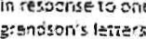one of Fi^{r}. | Outcome Fictic•m. 5tcr,• on a fabte  Greater Depth from clitferent point of viev.' | Outcome Fiction: •Mite a stery set •.n the Stone Age Greater Depth: Write ('cm the PCV ot person from the Stone Age | Outcome  Persuasion: le3tlet persuading ror the protection of Ine  Grenter Depth a tee: Cite naout enclEñEerect sea ctež:ures | Outcome  Fiction: story on the lerJEu:ee  Eerlie 30hettY  Gtenter Depth  Include o settlng taUteto lezd from ene P!ace noth | Outcome toutin  ParisiEOp;  Greater Depth  5ect;on Of resey:nee F'tr15
Suggested  hcadinss | Water. water everywhere  One litite drop  Rivers, lakes, oceans and seas  Where m we!Ëes take me |  | What's betow the surface? Deep, deep down |  | Journeys  Voyages anti discoveries
Larnins behavicur | Coifat-'0f3ii01 | Frianctship | flexibility |  | Imagination | Resourcdutness
Science | Anim615 Including humans tautr;ticn, and muscles)  Be in stud of rocks coastal r£ ;ons |  | Ccntirve rocks (tyaes of rock i;nkecl to age) | Forces arg meanets (linked to pc!es) | Plants | Liiht
History |  |  | Cha%es if, Brita;.r from  Age Ace |  | Tne achievements of the earliest civiliseticns  (Sum,et, Il'Kius, Egypt, 5hnns Dynesty) common themes e.a. early vwl:ir, | In depth study oi Ancient Eitpt the achievements oi the earllest civilizations
Geography | Where have you been cn holidav?  UK €ecgcaphicel regi0T5 inorth west. mic113rc$s etc} Coastal regicfi$  Features —  coa ^{t}:t5. cceons | '"Va•.er cycle  Arctic circle  Mountains |  | Gloz•al geographicol reEi0P5  Locationat knowledge — oceans, hemispheres, Pole South Pole, anci Antarctic | Rivers  Link with — ear',v civlllsatlorts that drew or, rivers | MEP akills^{r} —world countries, world map
 |  | Snc•.v zene in 3 cuttiü. shepir,g.joininž. iinishiü  Select and use range ci materi3is |  |  | Oe;ign end make a bridse cross moat Into the citadel — research bncl evatuete bridges, test materials evaluate | Creete 5 bee a íire(fe design — textiles patchwork)
Art | 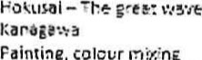 c,ff |  | 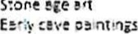 | Femi outs' F01yne;a,^{r} see or Bests of the |  | Steven Brown —Gif¥tfe pencil  crev,'in s o ms

Writing assessment grids for each year group have been included in Pathways to Write for teachers to use as a tool to support assessment Of Ef•OUPS or individuals, Each grid provides the whole year group currÀculum on a single page for ease of reference,
 | tóthpOlùon: plint1ii1É, |  |  | Compo%ltlon: | Compositlon:  Appt$ltyg gtammar |  |  |  | Transcrlption: Spelling t-lz
 | of the |  | and  Oi | selêcrilli ItiSt st•.ov.iç fist a di5v: diliCt ill  •are, | • they have read Nstinsuish  Exerthe  toachieve  Use the such t t"it | Ot purposec  models fortheit awn  !atuuszeotspeechanJ and  of  2correctly precive'.y to er.h•noce and  i  "Cit' |  |  | appropriate Form choosethe  to  ambiguity  listterret},'
 | the  to at;d the  (tat to use |  |  | to  V',e a ot to ecl•.egiUn (e.g.  6•Jûeóižts ot aitd plcce,  Bide | netn corn:'.i0ted ccrautr•  INF): utt.ižg  i¿ngtit to  Useverb cot"istQi1t.jVûild  Into' Z.  it 15  torn:s suci' •25 the ot  Use lheretge UI punctuation taugllt at  - ans t') irdia•.e  - arg  Coor" to 1st'  COQiu and •.0 mar).  to ivdie•.e |  | tgs:  stage 2 t: | pl•.rases i'Wüdng  tee ii'clú"iN  their  totjñ2i | 'ron éi:uteá that Include from 2  rules and pattž•ns, in  at•sd letters spelkrgotmcst and  most words tican thetearS/ fist uve a dlcti01yaty check of uncommon or ntcre  Malt8tðið at speed
 |  | or •in O | cuments
There several documents in addition to the planning to suppoft teachers that have been referred to throug ^{h} out this In summary these are:
Texts and Mastery Skitts Overview
Reading and Spoken Language Overview Progression in Mastery Sk01s Document
Feature Keys Progressìon Document
Writing Assessment Grids: Meat* 1 to Year 6 (included in 2020 with new package)
Cur•rìcutum Map (included. tn 2020 with new package)

